33.43: a) 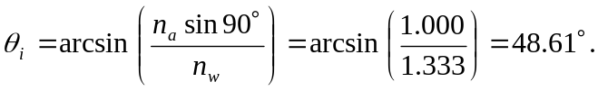
The ice does not come into the calculation since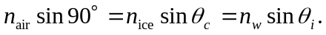
b) Same as part (a).

